**DAILY ONLINE ACTIVITIES SUMMARY**

|  |  |  |  |  |  |  |  |  |
| --- | --- | --- | --- | --- | --- | --- | --- | --- |
| **Date:** | **21-05-2020** | | | | | **Name:** | **Nihal Rafiq** | |
| **Sem & Sec** | **4th A** | | | | | **USN:** | **4AL18CS052** | |
| **Online Test Summary** | | | | | | | | |
| **Subject** | | **Microcontroller and Embedded System** | | | | | | |
| **Max. Marks** | | **30** | | **Score** | | | **13** | |
| **Certification Course Summary** | | | | | | | | |
| **Course** | **Introducing Coding for Beginners : an HTML and CSS Online Course** | | | | | | | |
| **Certificate Provider** | | | **BitDegree** | | **Duration** | | | **60 hrs** |
| **Coding Challenges** | | | | | | | | |
| **Problem Statement:**  **1. Write a c program to create singly linked list (SLL) with n elements and reverse the element using c.**  **2. Write a C program to construct a singly linked list by removing duplicate elements in the sorted linked list**  **3. Write a C program to implement SRTF process scheduling** | | | | | | | | |
| **Status: Executed** | | | | | | | | |
| **Uploaded the report in Github** | | | | | **Yes** | | | |
| **If yes Repository name** | | | | | **https://github.com/nihal-art/lockdown-coding** | | | |
| **Uploaded the report in slack** | | | | | **Yes** | | | |

Online Test Details:

Today's online test was on 1st Module of Micro controller and embedded systems (18CS44).The duration of online test was 40 minutes from 10.00am to 10.40am included of 30 questions. The marks obtained by me is 13/30.

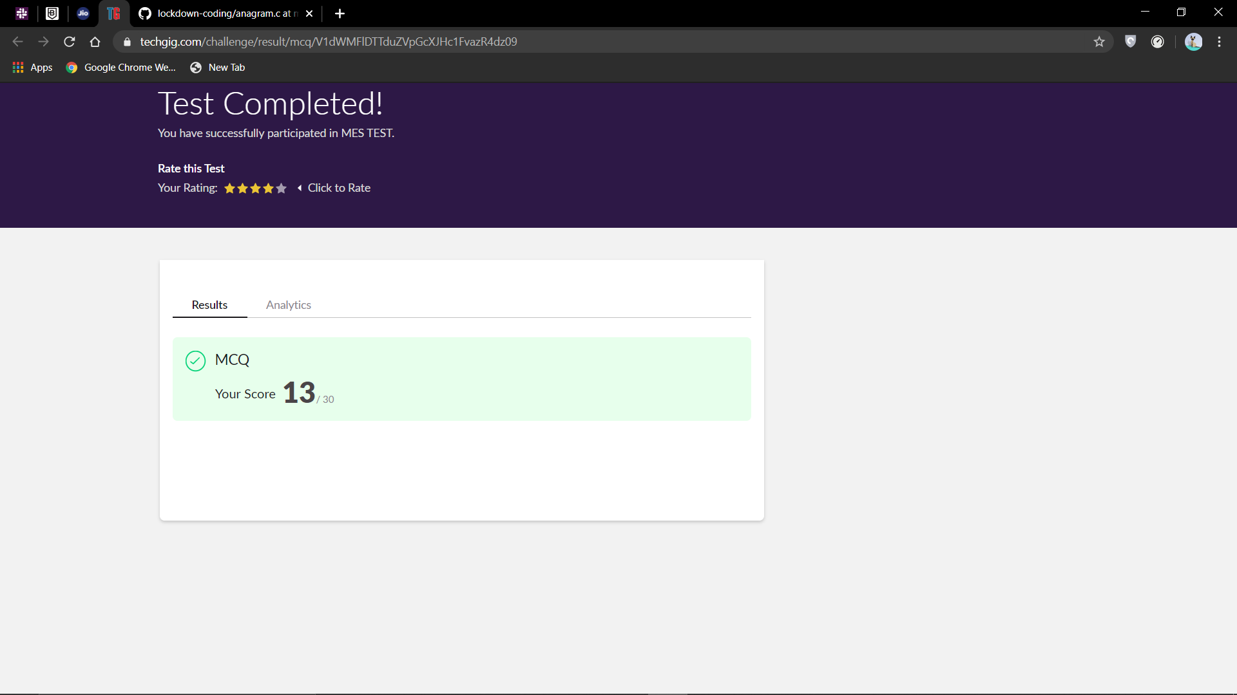

Certification Course Details:

I have opted my Online Certification Course in BitDegree. The course which I have opted is Introducing Coding for Beginners: an HTML and CSS Online Course

This course covers the following topics:

* Basic web development
* Creating forms, buttons and other elements
* HTML coding basics
* CSS basics

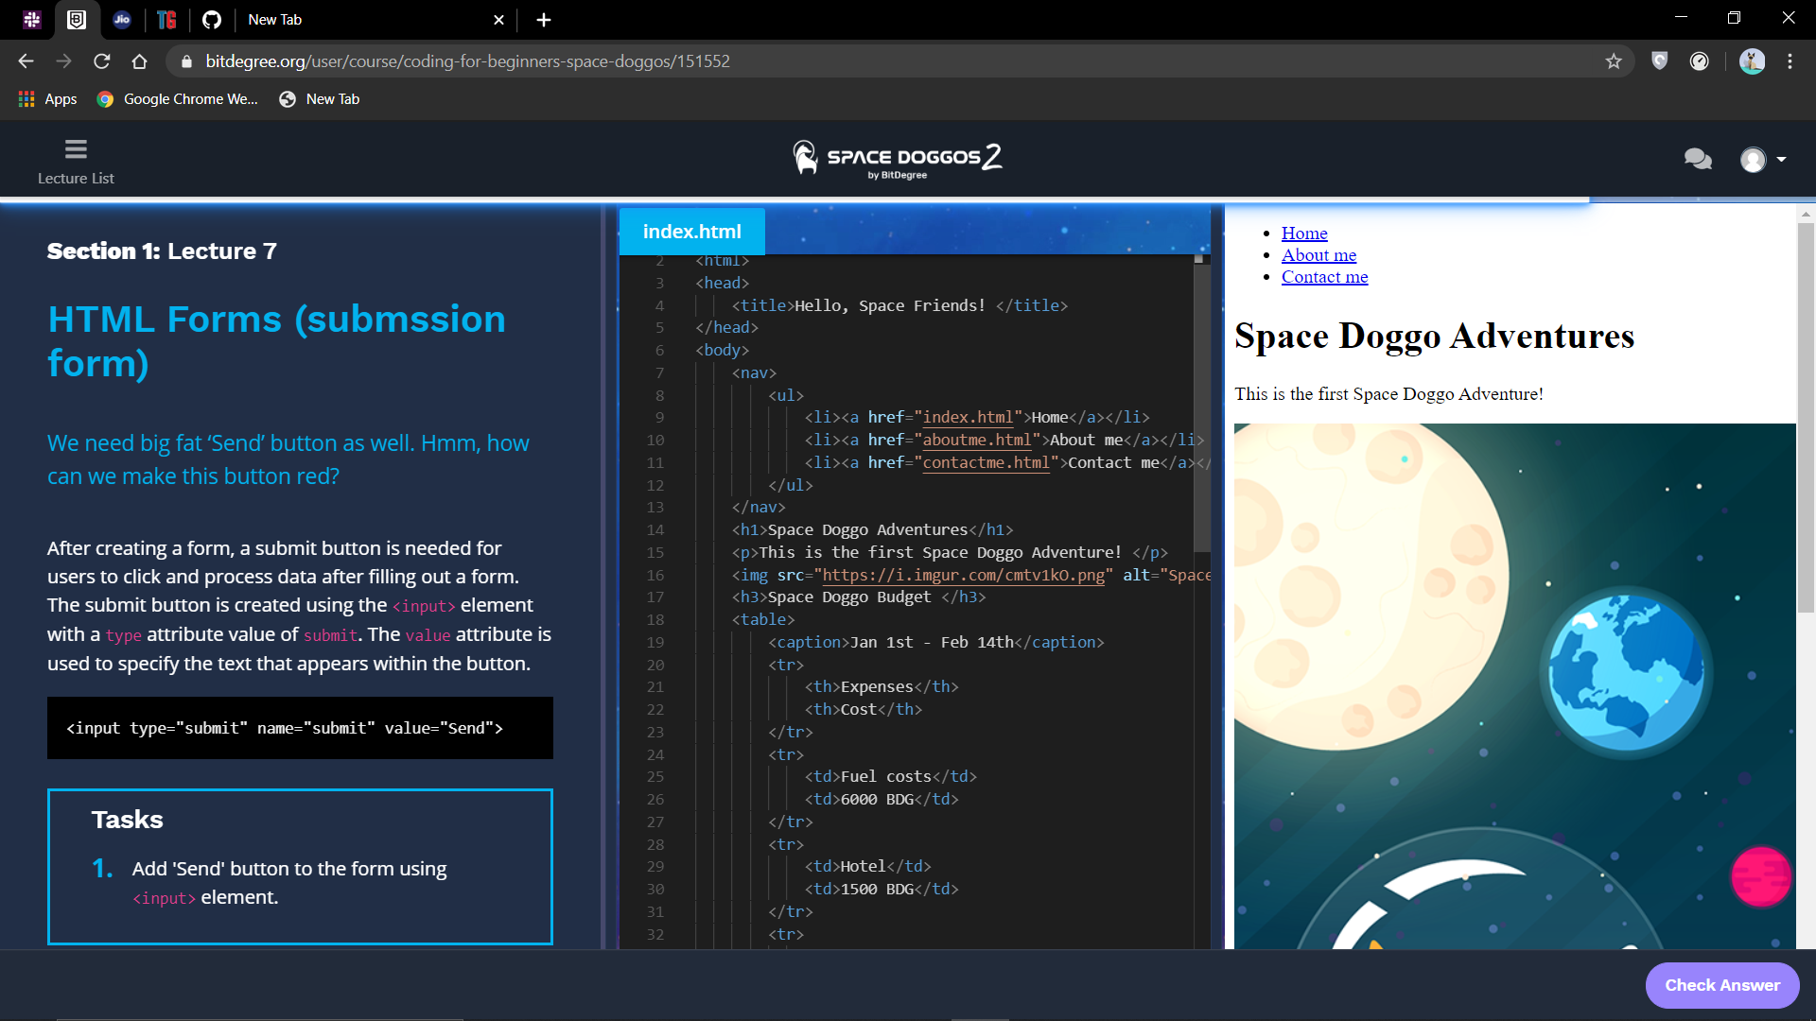

Coding Challenges Details:

1. Write a C program to create singly linked list (SLL) with n elements and reverse the element using c

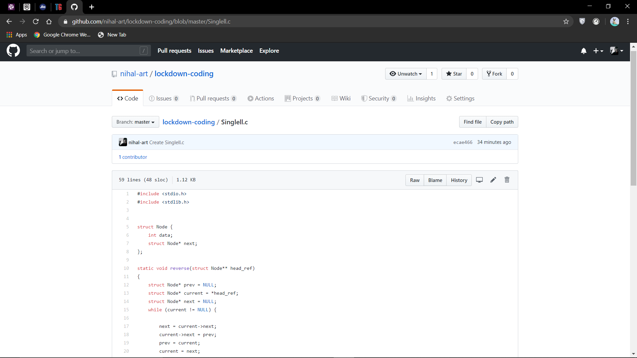

2. Write a C program to construct a singly linked list by removing duplicate elements in the sorted linked list  
Description: Take a sorted list and traverse the list. Compare the current node element with next adjacent node. If it is same then delete second element, if not retain. Finally print the resulting list.  
Sample output: Given list {1,2,2,3,3,3,4} Resulting list{1,2,3,4}

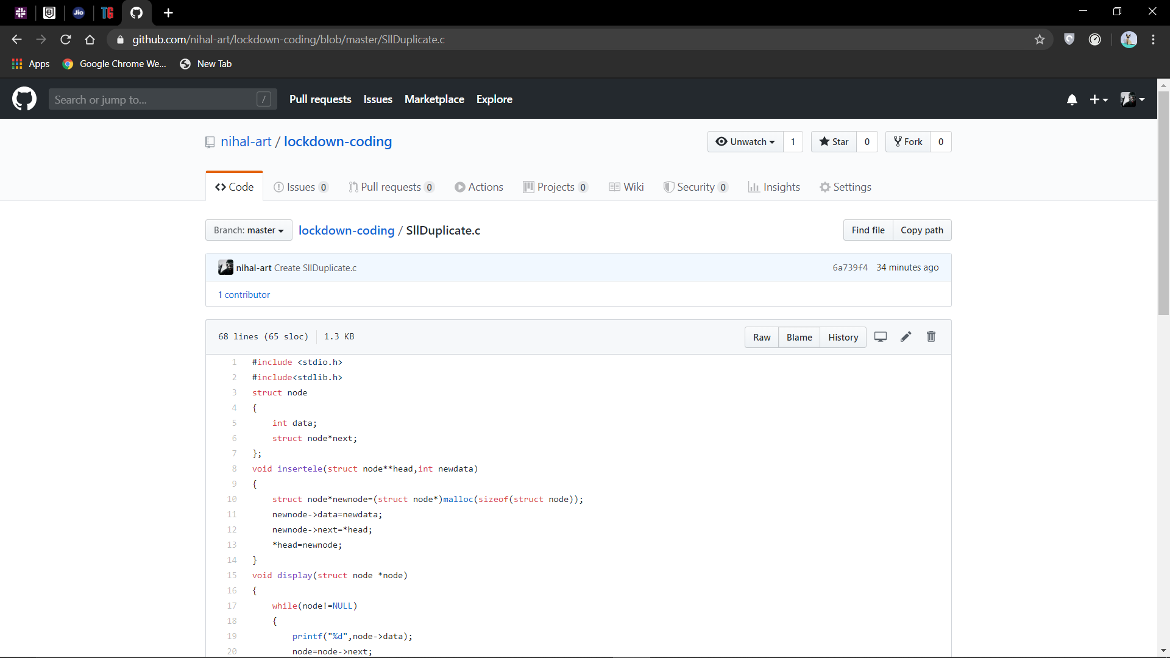

3. Write a C program to implement SRTF process scheduling.  
Input: A set of processes with their burst time and arrival time

Output: The processes scheduled based on the arrival time and a smaller burst time

